 | 12.1.49 Editors - Geometry Nodes Editor - Header - Add Menu - Hair - Read
Table of content
Detailed table of content 1
Add menu - Hair - Read 2
Curve Info 2
Curve Root 3
Curve Segment 3
Curve Tip 3
Hair Attachment Info 4

Detailed table of content
Table of content
Detailed table of content 1
Add menu - Hair - Read 2
Curve Info 2
Output 2
Curve Index 2
Curve ID 2
Length 2
Direction 2
Random 2
Surface UV 2
Curve Root 3
Output 3
Root Selection 3
Root Position 3
Root Direction 3
Root Index 3
Curve Segment 3
Output 3
Segment Length 3
Segment Direction 3
Neighbor Index 3
Curve Tip 3
Output 3
Tip Selection 3
Tip Position 3
Tip Direction 4
Tip Index 4
Hair Attachment Info 4
Input 4
Surface Geometry 4
Surface UV Map 4
Output 4
Attachment UV 4
Attachment is Valid 4
Surface Normal 4

Add menu - Hair - Read

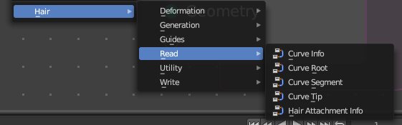
Hair nodes are Node Groups found in the Essentials Library included with Bforartists. They differ from the other nodes in the add menu due to being mid level node groups instead of individual low level nodes.

You can enter the node tree by clicking at the icon up right. Tab to leave the node tree. And you can of course also edit the node tree.



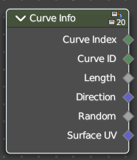
Curve Info
Reads information about each curve.

Output

Curve Index
Index of each curve.

Curve ID
ID of each curve.

Length
Length of each curve.

Direction
Direction of each curve.

Random
Random Vector of each curve.

Surface UV
Attachment surface UV coordinate of each curve.

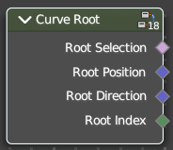
Curve Root
Reads information about the root point of each curve.

Output

Root Selection
Boolean selection of curve root points.

Root Position
The position of a root point of a curve.

Root Direction
Direction of the root segment of a curve.

Root Index
Index of the root point of a curve.

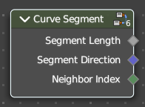
Curve Segment
Reads the information of the curve segment before the current point.

Output

Segment Length
Length of the segment

Segment Direction
Direction of the segment

Neighbor Index
Index of the neighbouring point on segment.

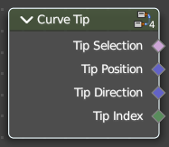
Curve Tip
Reads information about the tip point of each curve.

Output

Tip Selection
Boolean selection of the tip points.

Tip Position
Position of the tip point of a curve.

Tip Direction
Direction of the segment of the tip point of a curve.

Tip Index
Index of the tip point of a curve.

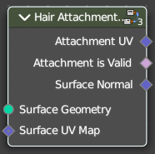
Hair Attachment Info
Reads attatchment information regarding a surface mesh.

Input

Surface Geometry
Surface geometry of the curve attachment.

Surface UV Map
Surface UV map used for attachment.

Output

Attachment UV
Surface attachment UV coordinate stored on each curve.

Attachment is Valid
Is the attached UV coordinate valid?

Surface Normal
The normal direction of the surface mesh at the attachment point.

